You are given a positive integer n representing n cities numbered from 1 to n. You are also given a **2D** array roads where roads[i] = [ai, bi, distancei] indicates that there is a **bidirectional** road between cities ai and bi with a distance equal to distancei. The cities graph is not necessarily connected.

The **score** of a path between two cities is defined as the **minimum** distance of a road in this path.

Return *the* ***minimum*** *possible score of a path between cities* 1 *and* n.

**Note**:

* A path is a sequence of roads between two cities.
* It is allowed for a path to contain the same road **multiple** times, and you can visit cities 1 and n multiple times along the path.
* The test cases are generated such that there is **at least** one path between 1 and n.

**Example 1:**

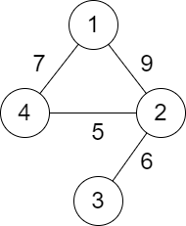

Input: n = 4, roads = [[1,2,9],[2,3,6],[2,4,5],[1,4,7]]  
Output: 5  
Explanation: The path from city 1 to 4 with the minimum score is: 1 -> 2 -> 4. The score of this path is min(9,5) = 5.  
It can be shown that no other path has less score.

**Example 2:**

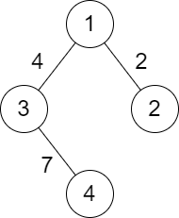

Input: n = 4, roads = [[1,2,2],[1,3,4],[3,4,7]]  
Output: 2  
Explanation: The path from city 1 to 4 with the minimum score is: 1 -> 2 -> 1 -> 3 -> 4. The score of this path is min(2,2,4,7) = 2.

**Constraints:**

* 2 <= n <= 105
* 1 <= roads.length <= 105
* roads[i].length == 3
* 1 <= ai, bi <= n
* ai != bi
* 1 <= distancei <= 104
* There are no repeated edges.
* There is at least one path between 1 and n.